1. Assignment #3: Program flow with turtles

**Master in Informatics and Computing Engineering  
Programming Fundamentals  
Instance: 2018/2019**

# 1. Introduction

***Goals****: to write programs using for loops with graphics made from Turtle.*

***Pre-requirements (prior knowledge)****: Turtle class and for loops, as in Lecture #3*

***Rules****: You may work with colleagues, however, each student must write and submit in Moodle his or her this assignment separately. Be sure to indicate with whom you have worked. We may run tools to detect plagiarism (e.g.duplicate code submitted).*

***Deadline****: 8:00 Monday of the week after (15/10/2018)*

***Collaborators****:*

*201806554*

# 2. Regular polygons

Write a program that asks the user for the number of sides, the length of the side, the border color and the fill color of a regular polygon. The program should draw the polygon and then fill it in.

Then copy the program (regular.py) here:

import turtle

wn = turtle.Screen()

tt = turtle.Turtle()

n = int(input("Number of sides: "))

c = int(input("Length of the side: "))

bc = input("Border color: ")

fc = input("Fill Color: ")

tt.pensize(5)

tt.color(bc)

tt.fillcolor(fc)

tt.begin_fill()

for i in range (n):

tt.forward(c)

tt.left(360/n)

tt.end_fill()

wn.exitonclick()

# 3. Polygons with turtles

Use *for* loops to make a turtle draw these regular polygons (all sides have the same length and all inner angles have the same value):

* A square
* An equilateral triangle
* A hexagon (six sides)
* An octagon (eight sides)

Then copy the program (polygons.py) here:

import turtle

wn = turtle.Screen()

tt = turtle.Turtle()

for i in range(4):

tt.forward(100)

tt.left(360/4)

for i in range(3):

tt.forward(100)

tt.left(360/3)

for i in range(6):

tt.forward(100)

tt.left(360/6)

for i in range(8):

tt.forward(100)

tt.left(360/8)

wn.exitonclick()

# 4. For and range

Write a program that for every *even* number n between 20 and 250 prints

Python turtle number <n> is cool!

Copy your program (range.py) here:

for i in range(20,251):

if i % 2 == 0:

print("Python turtle number <" + str(i) + "> is cool!")

# 5. Turtle clock

Write a program that produces a turtle clock similar to the one shown below:

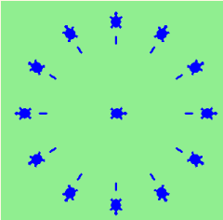

Copy your program (clock.py) here:

import turtle

wn = turtle.Screen()

wn.bgcolor("lightgreen")

tt = turtle.Turtle()

tt.shape("turtle")

tt.color("blue")

size = 10

tt.pensize(3)

tt.stamp()

for i in range(12):

tt.right(30)

tt.goto(0,0)

tt.penup()

tt.forward(100)

tt.pendown()

tt.forward(10)

tt.penup()

tt.forward(20)

tt.stamp()

wn.exitonclick()

# 

# 6. Stars

Consider a star-like shape, where each side consists of a straight line with a stamp at its end:

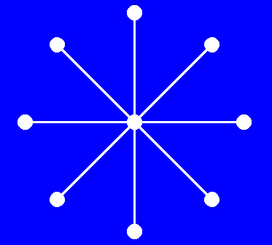s

Write a program that draws this shape, with the number of sides provided by user input.

Copy your program (**stars.py**) here:

import turtle

wn = turtle.Screen()

wn.bgcolor("blue")

tt = turtle.Turtle()

tt.shape("circle")

tt.color("white")

size = 10

tt.pensize(3)

tt.stamp()

ns = int(input("Number of sides: "))

for i in range(ns):

tt.goto(0,0)

tt.forward(200)

tt.stamp()

tt.right(360/ns)

wn.exitonclick()

# The end.

*FPRO, 2018/19*